Tungsten Gate Mesh
Etching Procedure

7/26/2010
The University of North Carolina at Chapel Hill and Xin Ray
Derrek Spronk and Emily Gidcumb

- Cut the tungsten metal sheets into 1’’ by 2.5’’ rectangles if using the Argus 3 photo mask. Other photo masks may require slightly different sizes.

- Tungsten Metal Cleaning: This is to be done before photolithography.
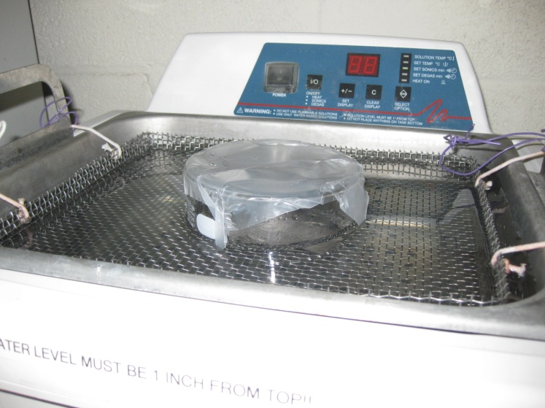
- Wipe excess dirt and old photo resist off,
if present, with NMP (n-methyl pyrrolidone)
  - Heat NMP to 100C
- Put tungsten squares in a glass container.
- Sonicate in Methyl alcohol for 15 minutes
- Sonicate in Acetone for 15 minutes
- Sonicate in Isopropyl alcohol for 15 minutes
  - Note: When sonicating, cover the
glass ware with parafilm and make
sure that the water level is at the
appropriate height, at least filled up
to one inch from the top of the
sonicator.
- Rinse with deionized water
- Blow dry with Nitrogen gas
- Dry on Hot plate at 100C for 5 minutes

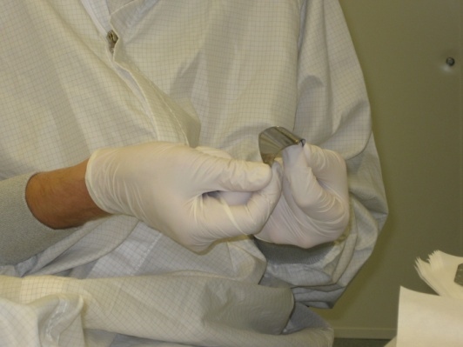

- Spin coating:
- Flatten sample as much as possible by hand
  - Do not introduce any sharp bend lines.
- Place on spin coater and hit “Vacuum”
- Apply MCC Primer 80/20 with a pipette
- Spin with program ‘S’:
  - 3000 rpm for 30 seconds
  - Select program, hit “Run”
- Hit “Vacuum” to release the tungsten and move
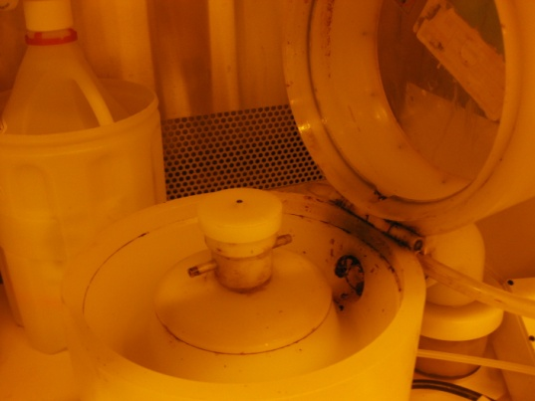
immediately to hot plate, bake for 1 minute at 100C
- Remove from hot plate, move back to spin coater and hit
“Vacuum”
- Apply KMPR 1010 Photo resist
- Spread photo resist around with pipette to cover better
and eliminate bubbles
- Spin with program ‘T’:
  - 500 rpm for 5 seconds
  - 1000 rpm for 30 seconds
- Move immediately to hot plate, bake for 12 minutes at
100C and allow to cool to room temperature
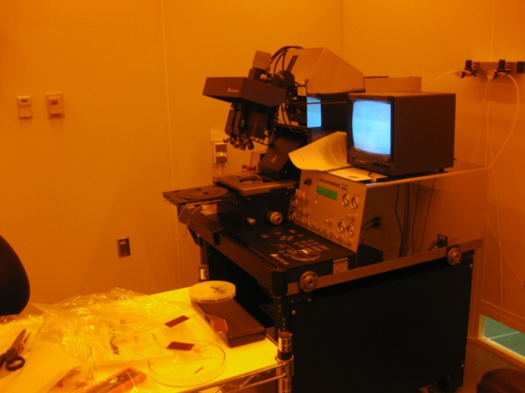
- Photolithography:
- Tape mask to 7” square glass plate with scotch tape
- Load mask into Mask Aligner
  - Hit “Change Mask”
  - Toggle vacuum on with “Enter”
  - Load mask
  - Hit “Change Mask”
- Load sample directly under the mask
  - Hit “load”
  - Confirm with “enter”
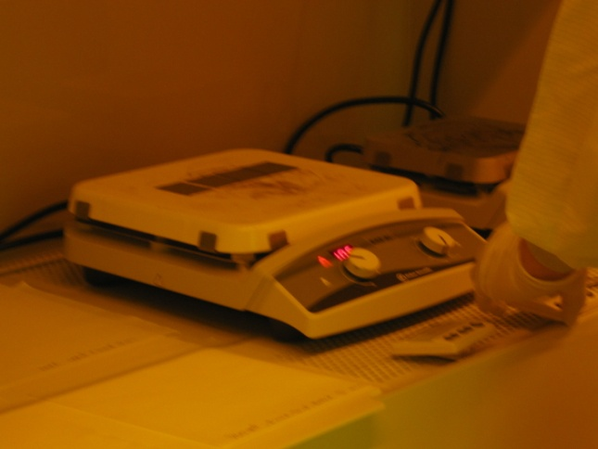
  - Align metal below desired mask portion
  - Hit “Enter”
  - Hit “enter” to ignore loss of vacuum warning
- Settings:
  - 100um alignment gap
  - hard contact during exposure
  - Exposure time: 40 sec
    - To change hit “edit parameters”
    - Use up and down arrows to desired value
    - Hit “edit parameters”
- Expose for 40 sec
  - Hit “expose”
- Unload sample and immediately move to hot plate,
bake for 2 minutes at 100C
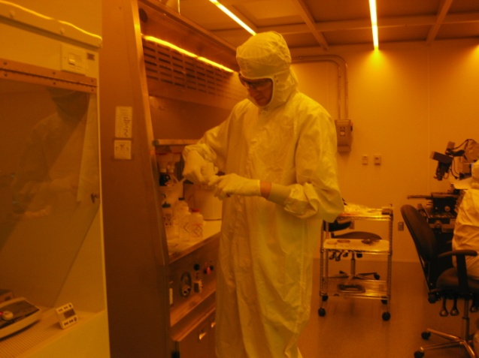
  - Pattern should appear after the first minute, if
sooner that is an indication of over exposure
- Place sample in SU-8 developer bath for 2 minutes
- Rinse with Isopropyl Alcohol
  - If the pattern appears white at all, return to
developer
  - Repeat, until there this no longer occurs
- Rinse with deionized water
- Dry with Nitrogen gas
- (optional) check film thickness with profilometer,
Usually with this procedure film is around 22-23 um,
uniformity is ±1 um

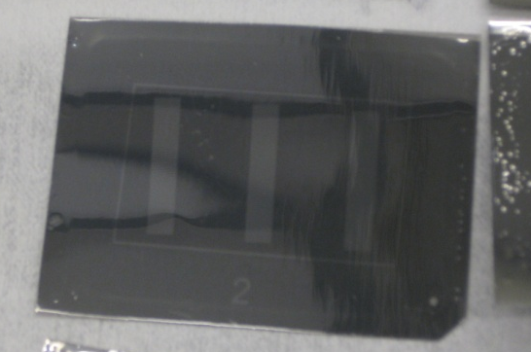

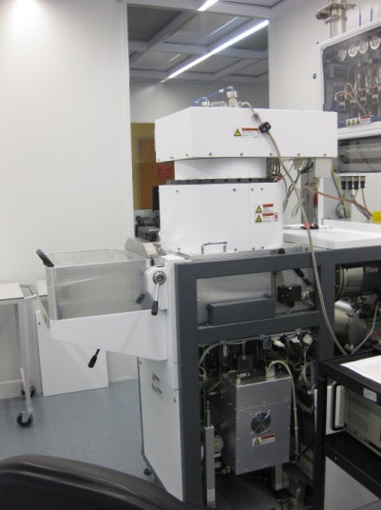
- Etching with DRIE (Deep Reaction Ion Etch):
- Run Clean O2 6’’ for 30 minutes
- Bend the tungsten metal to ensure it is as flat as possible
- Put a minimal amount of thermal paste in the four corners of the
tungsten sample.
- Press sample onto center of Al wafer
  - Up to three samples have been etched simultaneously
with success, but they cannot touch one another
- Use the other Al wafer to compress sample flat or the hard end of
a clean room q-tip
- Check that the metal is laying as flat as possible on the wafer
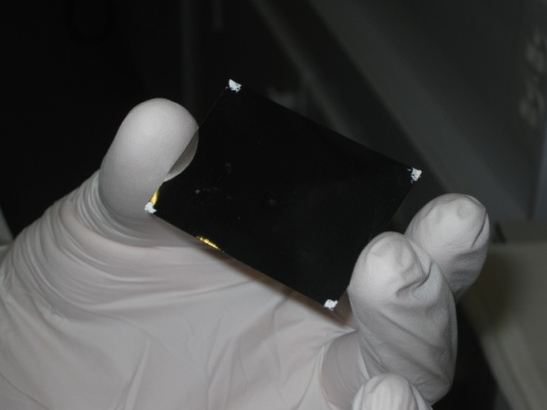
- Load Al wafer into reactor
- Run “Tungsten Etch 2” with the following settings (Default):
  - SF6 = 200 sccm
  - Ar = 200 sccm
  - Pressure = 4.5E-2 mbar
  - He Pressure = 1E1 mbar
  - Source Generator = 1200 W
  - H Power = 75 W
  - H Time = 30 ms
  - L Power = 0 W
  - L Time = 70 ms
  - Position from source = 150 mm
  - Step time = 5 minutes
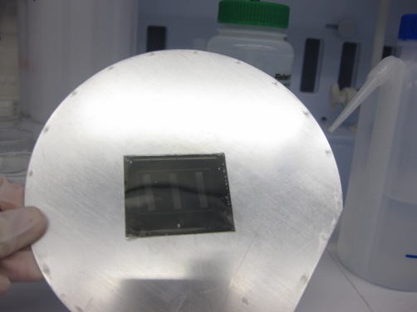
    - This is to prevent overheating
    - After etching has begun this can be reduced
to 3 minutes, 2 minutes, 1 minute, or 30
seconds depending on how much etching is
left
- Remove the wafer from the DRIE
- Use tweezers to remove the metal from the wafer, and put
the waste in a designated waste container for metals

- Post etch cleaning
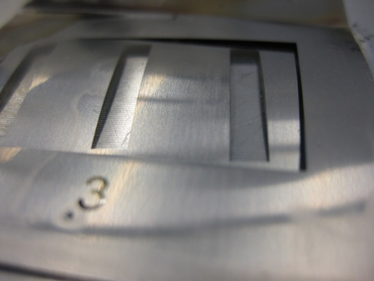
- Wipe off the paste with deionized water
- Clean the aluminum wafer with deionized water and acetone
- Remove the remaining photo resist with NMP
  - Heat the tungsten in NMP on a hot plate to 100C when
removing the photo resist
- Repeat the Tungsten Metal Cleaning, step 2

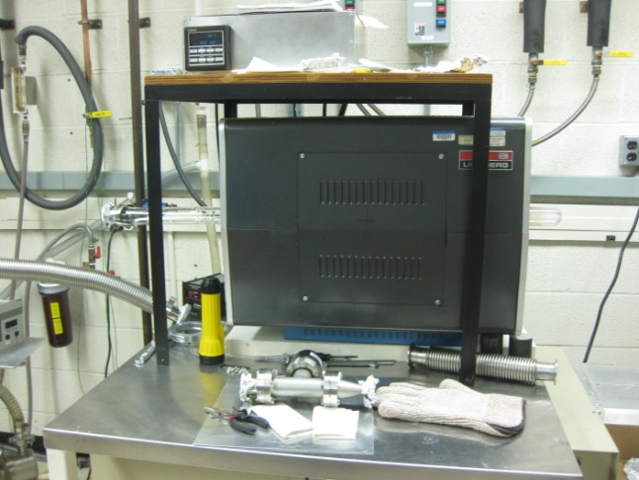
- Post etch annealing
- Anneal in a vacuum furnace for 3 hours at 500C

- Post etch storage
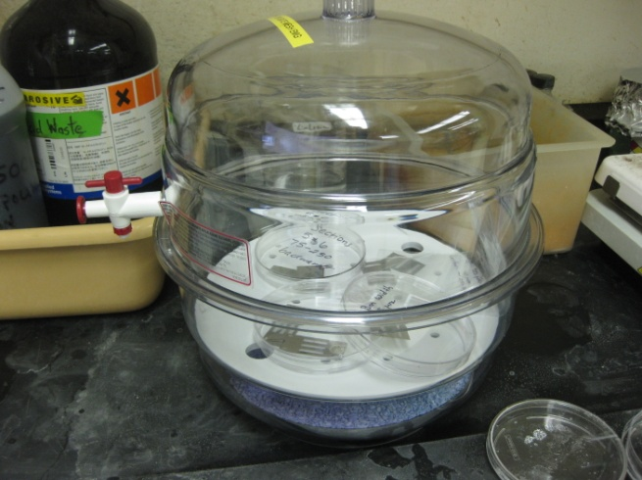
- Store in a vacuum desiccator in a Petri dish until used.

